Ready Steady Grow! (field to fork)
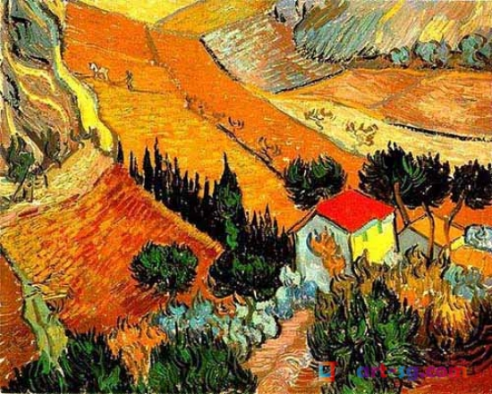
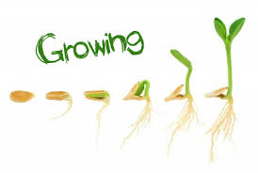
Starters
Alive or never alive? You decide. Can you make a lists of things for each category?
Think of some exciting adjectives to describe your favourite foods. Now can you think of a good simile?
Can you use construction or junk modelling to design and make your own farmyard?
Main Course
Plant a seed and watch it grow. Can you record what you see each week? Estimate how long you think it will take to grow.
1 chicken has two feet, 2 chickens have 4 feet, can you carry on the pattern? Can you do the same with other farm animals?
Have a look in your kitchen and make a list of all the places your food comes from. Can you find them on a map? How far have they travelled?
Dessert
Do a Google search for farm paintings- choose your favourite and then create your own.
It’s fun to grow things at home. Can you plant some seeds that will make you a super salad at the end? Try designing your own delicious salads with a trip to the supermarket- don’t forget to write down your recipe and method. (and take a photo!)
Breakfast is the most important meal of the day- why? Can you design a breakfast for a sports person? Explain your choices
Play the farm to fork game (attached) can you design your own game?
.

